

**Tour Guide Application**

**"Tour Guide"**

**Presented by**

**Malek Jamal Hamdan: 31601002038**

**Mohammed Emad: 3161001006**

**Supervisor: Dr.Magdi Bseiso**

Submitted in Partial Fulfillment of the Requirements for Bachelor Degree in Software Engineering

**Prince Abdullah Bin Ghazi Faculty of Information & Communication technology**

**Al-Balqa' Applied University**

**Salt- Jordan**

**31/08/2021**

## DECLARATION

I hereby certify that this material, which I now submit for assessment on the programme of study leading to the award of Bachelor of Science in *(Software Engineering)* is entirely my own work, that I have exercised reasonable care to ensure that the work is original, and does not to the best of my knowledge breach any law of copyright, and has not been taken from the work of others save and to the extent that such work has been cited and acknowledged within the text of my work.

Signed: Malek Jamal Hamdan, Mohammed Emad.

Student No.: 31601002038 , 31601001006.

Date: 31-08-2021.

## ABSTRACT

The tourism sector is an integral part of any sector in any country, and everyone must work to improve it and provide the necessary support for this sector.

In the year 220, the Corona pandemic began, which led to a decrease in tourism in Jordan.

So we had to find an alternative to identify non-Jordanians in ancient archaeological sites through the use of technology. Therefore, we developed a “**Tour Guide**” that serves us for this goal.

Table of Contents

1.chapter.1 Introduction 1

1.1 Inroduction 2

2.chapter.2 PLANNIONG PHASe 4

2.1 Inroduction to planning phase 5

2.2 Business profile 7

2.2.1 Tour Guide Mission 7

2.2.2 Tour Guide Vision 7

2.2.3 Tour Guide Services 8

2.4 Market Analysis 18

2.4.1 Strength 18

2.4.2 Opportnuity 18

2.4.3 Threats 18

3. chapter.3 Analysis phase 19

3.1 Introduction to analysis phase 20

3.2 Analysis Methodology 22

3.3 Conseptual Data Modeling 23

4. chapter.4 Design phase 25

4.1 UML and Description 26

4.2 Modeling with Enterprise Architect 26

4.2.1 Class Diagram 27

4.2.2 Use Case Diagram 28

4.2.4 Collaboration (State Diagram) 35

4.2.4.1 Tour Guide Activity. . . . . . . . . . . . . . . . . . . . . . . . . . . . . . . . . . . . . . . . . . . . . . . .35

4.2.4.2 User Signup. . . . . . . . . . . . . . . . . . . . . . . . . . . . . . . . . . . . . . . . . . . . . . . 36

4.2.4.3 User Login . . . . . . . . . . . . . . . . . . . . . . . . . . . . . . . . . . . . . . . . . . . . . . 37

4.2.4.4 User Rest Password. . . . . . . . . . . . . . . . . . . . . . . . . . . . . . . . . . . .. . . . . 38

4.2.4.5 Main Activity…………………………………………………………….

5. chapter.5 User Manual 40

5.1 Introduction 41

5.2 Hardware Requirements 41

5.3 Software Requirements 41

5.4 Figures of the project 42

6. chapter.6 rEferences 50

6.1 References 51

Chapter 1: Introduction



# Introduction

The tourist guide application provides information and pictures about the ancient archaeological sites in Jordan for users and also allows registration for the tourist guide as a service for tourists with a full display of the guide information such as photo, phone number and email, and the ability to request the guide from the user.

It also provides archaeological sites on the map, and through the application, the automatic reading feature can be turned on for a better and easier user experience

The target audience for the tour guide application can be generally tourists or non-Jordanians. With just a few clicks on the app, you can see and read the correct information about Jordanian archaeological sites.

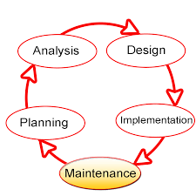

Work began on the system with the ***Planning Phase***, and the purpose of their study is to establish a clear vision of the nature and extent of system problems. We started asking for important information that helped us identify the system specifications **(system's requirements)**, and found out the system's mechanism. Preparation of the feasibility study, implementation plan, and evaluation of this study is carried out through the planning phase to know how to send requests, receive and respond to each phase of the project.

All system requirements and specifications are prepared in ***Analysis Phase***, the next phase of *system development life cycle* **(SDLC)**. We preferred using analysis methodology called *"object oriented analysis methodology"* **(OOA methodology)**, which mainly used class diagram, use case diagram, and other types of diagrams that used in this methodology.

The new version of system presented in ***Design Phase***, in which team members working in a special framework called **"Android Studio"**, that consists of set of different capabilities, which mainly build the design phase. We took under consideration the major steps and activities that used to build design phase; such as input design, output design, control design, and access layer design, which the Tour Guide system requires when registration and display information.

The final phase of building our project was ***Implementation Phase***, in which all system specifications, needs, and requirements are mixed together to build the final system. This phase is made up from seven different activities started by coding and ended by systems maintenance. During this phase, the system built and evaluated its performance in other activities in this phase, enhanced by IT-tools that made the system interfaces more flexible, and user's friendly of users.

"*After Tour Guide App goes through main phases in SDLC, the new model of the system becomes more efficient, reliable, user's friendly, and the developers can maintain it in easy way.***"**

Chapter 2: Planning Phase



# Introduction to Planning Phase

System's Development Life Cycle ***(SDLC)***, is one of the most common and important concepts that are used in Business Environment. This concept can present as closed cycle that presents set of different phases that use to build your own system.

SDLC built mainly from the following phases:

• Planning phase.

• Analysis phase.

• Design phase.

• Implementation phase.

• Operation, support, and security phase.

Each of these phases has its own activities that are very important to complete the final and functional phase, aims to build your system successfully. You have to note that the first phase is planning phase, in this case, the system's analysts start to evaluate the proposed project and determine its feasibility.

The main activities that will cover in this phase:

• **Business profile:** consists of mission, vision, and core values, services, and organization's structure chart.

• **Current business description:** includes the history of the current system, current system description, and its difficulties.

• **Problems definitions:** includes the major problems that face the current system, nature and discussion of each problem.

• **System's scope:** talks in summary about the essential services that provided by the current system.

• **System's requirements:** presents the major requirement of the current system, either functional or non-functional requirements.

• **Strategic planning and SWOT analysis:** provides the main factors that affect the system on one hand, and the strategies to develop the system on the other hand.

• **Feasibility study:** *evaluates the system's feasibility*: technical, operation, and economic feasibility.

• **Implementation plan:** short plan that presents the major phases, that uses to build project infrastructure, with estimated time and cost.

*"Some of the previous activities will present in more details in the next phases of this project, mainly, the project built from the following phases: planning, analysis, design, implementation, and testing."*

## Business Profile

### Tour Guide **Mission**:

### Our mission as a Tour Guide Application is to introduce tourists to ancient archaeological sites by displaying pictures and detailed information about each site separately.

### Tour Guide **Vision**:

### Our Vision is to become the number one mobile Tour Guide in the whole of Jordan and the all World about ancient archaeological sites in Jordan.

### **Our Services and Amenities**:

The **Tour Guide** application is an application that contains several pictures and information about ancient archaeological sites in Jordan. Through the application, a tourist guide can be requested if a tourist is in Jordan, and provides job opportunities for local residents.

We intend giving our users every reason to always use our App and we provide true information. These are the services we will offer as **Tour Guide** App :

**View pictures of archaeological sites in Jordan.**

**View information about archaeological sites in Jordan.**

**Request a tour guide.**

**Read information through voice Android.**

**weather condition.**

Chapter 3: Analysis Phase



## Introduction to Analysis Phase

Thesecond important phase that our project used is analysis phase, in which the overall objectives of the system in this phase is to understand the proposed project, to ensure that it will support the business requirements. The analysis phase involves end users and IT specialists working together to gather, understand, and document the business requirements for the proposed system. The main activities that this phase include:

* Requirements modeling:involves fact-finding to describe the current system, and to identify the major requirements of the new system such as outputs, inputs, processes, performance, and security techniques.
* **Data and Process modeling:** describes how to represent graphically system data and processes using object -oriented analysis methodology.
* **Development Strategies:** the operation of selecting the best development path is an important decision that requires companies to consider three key topics: the impact of the internet, software outsourcing options, and in-house software development alternatives.
* When talking about analysis phase, we have to know that we have set of different analysis techniques, the major techniques can classified into the following types:
* **Structured analysis methodology:** this technique mainly based on using something called data flow diagram to describe the major activities and data flow through the system processes.
* **Object oriented methodology:** this type of analysis based on using objects that may presents person, machine or something else.
* Other concept that we have to know in this important phase is team-oriented methods that describe the way that used to develop and analysis the system. There are two main methods are:
* **Joint Application Development (JAD):** a popular fact-finding method that brings users into the development process as active participation.
* **Rapid Application Development (RAD):** team-based technique that speeds up information system development and produces a functioning information system.

**"**Analysis phase needs strong analytical and interpersonal skills to build an accurate model of the new system. Analytical skills mean the ability to identify the problem, evaluate elements, and develop a useful solution. The interpersonal skills mean the ability communicate effectively with your team members on one hand, and the end users on the other hand."

## Analysis Methodology

In this project, we chose object-oriented methodology to analyze the system, whole system

Object oriented analysis considers as one of the most common techniques to analyze the system requirements, this process or method based on using objects, O-O analysis commonly used in the real world business application. The main result of using this method is a set of software objects that represent actual system users, things, transaction and event which allocate in the current system.

The most common language that used in object oriented analysis is UML that stands for Unified Modeling Language. It uses a set of different concepts that come from object oriented programming language there are set of different examples about them such as:

* Classes.
* Inheritance.
* Objects.
* Messages.
* Methods.
* Abstraction.
* Encapsulation.
* Polymorphism.

The fundamental idea behind an object-oriented (OO) language is object decomposition, breaking the complex software system down into its various objects, combining the data and the functions that operate on the data into a single unit, the object. Objects are discussed and built by modeling real-world instances. A typical OO system consists of a number of cooperating objects, each of which may or may not collaborate with other objects in order to achieve some task for the user. Real-world objects display the characteristic of high cohesion; they maintain a single theme or focus, in true, and software objects modeling real world objects.

Because of using this technique for analyzing our system requirements we have to use the following parts of UML diagrams:

• Use case diagrams.

• Class Diagram.

• Sequence diagrams and State diagrams.

## Conceptual Data Modeling

System's analysts perform data modeling during the systems analysis phase. It typically done at the same time as other requirements structuring steps. The conceptual data modeling is a representation of the organizational data. The major purpose of using conceptual modeling is to show as many rules about the meaning and interrelation among data as possible .The most common tool that used to model the database is Entity Relationship Diagram or shorted by ERD, which shows how the data organized in an information system. In this project, we present a virtual diagram for suggested system, you have to note that this diagram will be modify in the next phase of the project based on the system's requirements and specifications, the frication of this diagram will be presenting in the design phase.

Chapter 4: Design Phase



## UML and Description

Visual modeling has one communication standard: the Unified Modeling Language **(UML).** The **UML** provides a smooth transition between the business domain and the computer domain. Using the UML, all members of a design team can work with a common vocabulary, minimizing miscommunication and increasing efficiency.

Visual modeling captures business processes by defining the software system requirements from the user’s perspective. This streamlines the design and development process. Visual modeling also defines architecture by providing the capability to capture the logical software architecture independent of the software Language. This method provides flexibility to your system design since the logical Architecture can always be mapped to a different software language. Finally, with Visual modeling, you can reuse parts of a system or an application by creating Components of your design. These components can then be shared and reused by different members of a team allowing changes to be easily incorporated into already existing development software.

## Modeling with Enterprise Architect

**Enterprise Architect** is the visual modeling software solution that lets you create, analyze, design, view, modify, and manipulate components. You can graphically depict an overview of the behavior of your system with a use-case diagram. **Enterprise Architect** provides the collaboration diagram as an alternative to a use-case diagram. It shows object interactions organized around objects and their links to one another. The state chart diagram provides additional analysis techniques for classes with significant dynamic behavior. A state chart diagram shows the life history of a given class, the events that because a transition from one state to another and the actions that result from a state change. Activity diagrams provide a way to model a class operation or the workflow of a business process.

**Enterprise Architect** provides the notation needed to specify and document the system architecture. The logical architecture is captured in class diagrams that contain the classes and relationships that represent the key abstractions of the system under development. The component architecture is captured in component diagrams that focus on the actual software module organization within the development environment. The deployment architecture is captured in deployment diagrams that map software to processing nodes—showing the configuration of run-time processing elements and their software processes.

There are set of concepts that used in UML as following:

• **Use Cases:** represent the major functional requirements of your system.

• **Class Diagrams:** show the static structure of data and the operations that act on the data.

• **State Diagrams:** represent dynamic models of how objects change their states in response to events.

• **Sequence Diagrams:** represent dynamic models of interaction that happen between objects.

### Class Diagram:

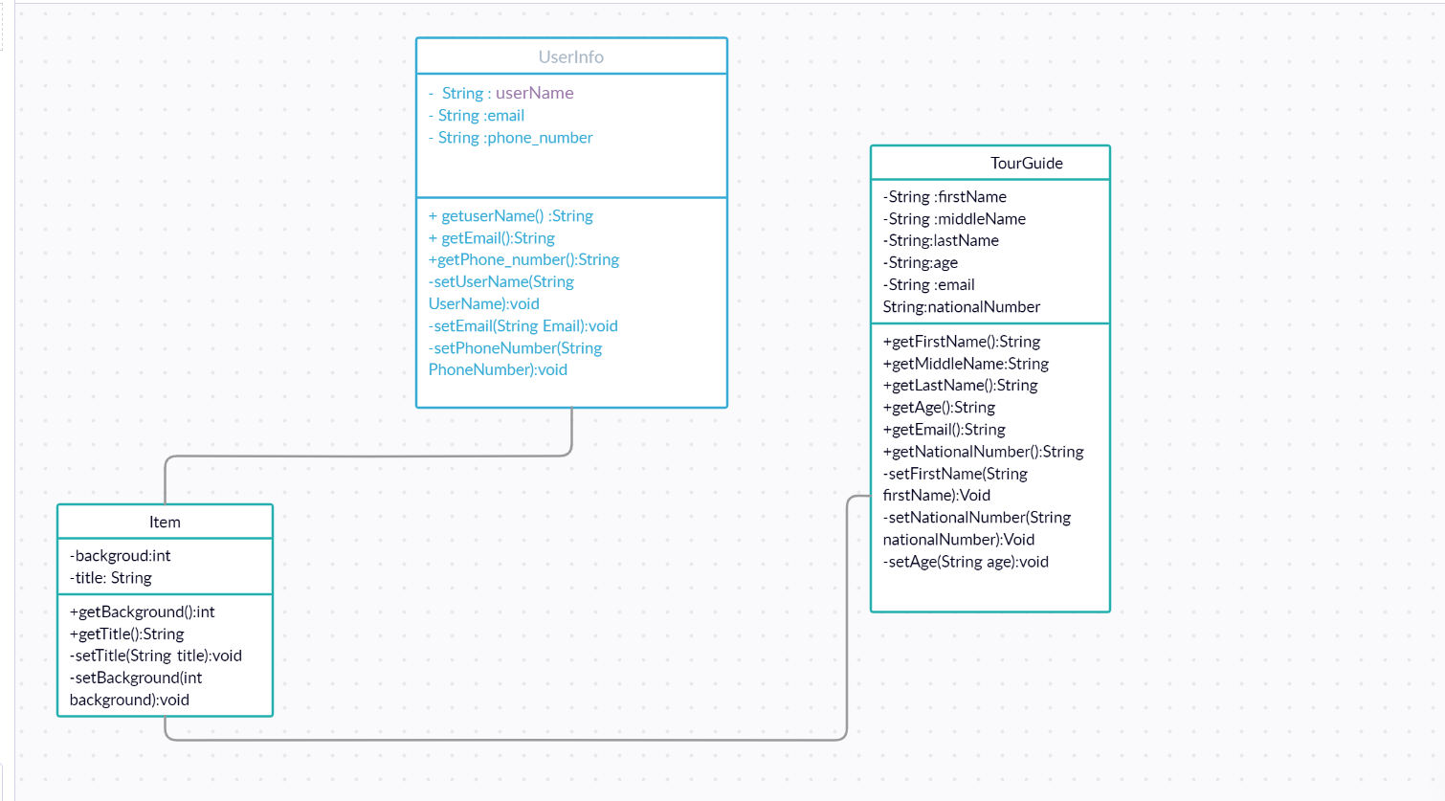

### Use case diagram:

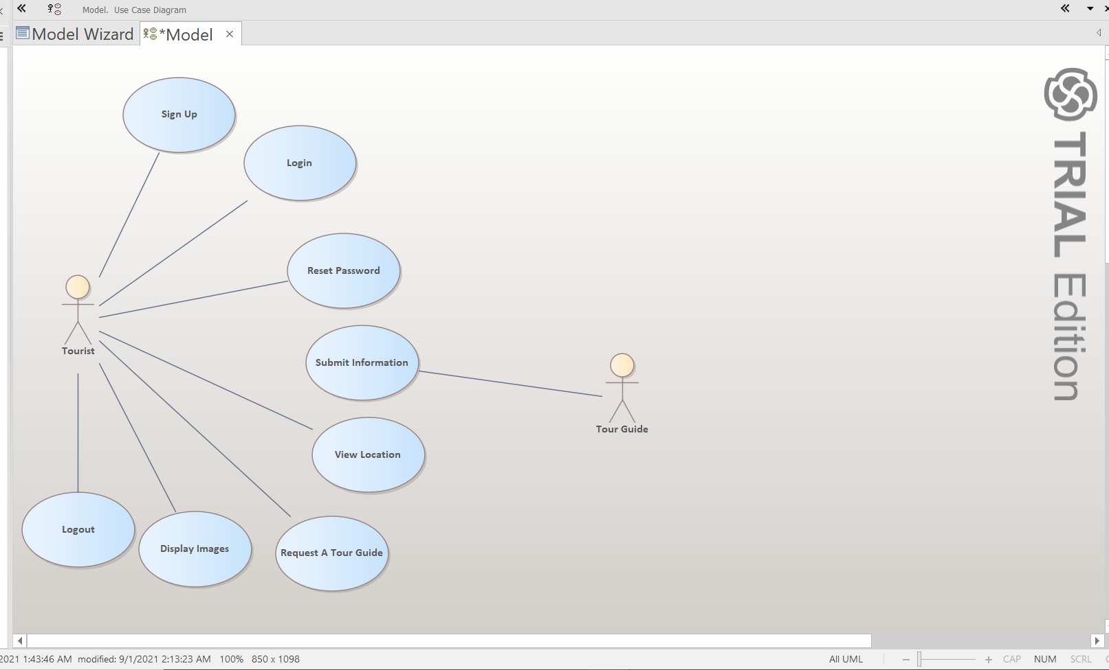

### Collaboration (State Diagram):

#### Admin Activity



#### User Signup

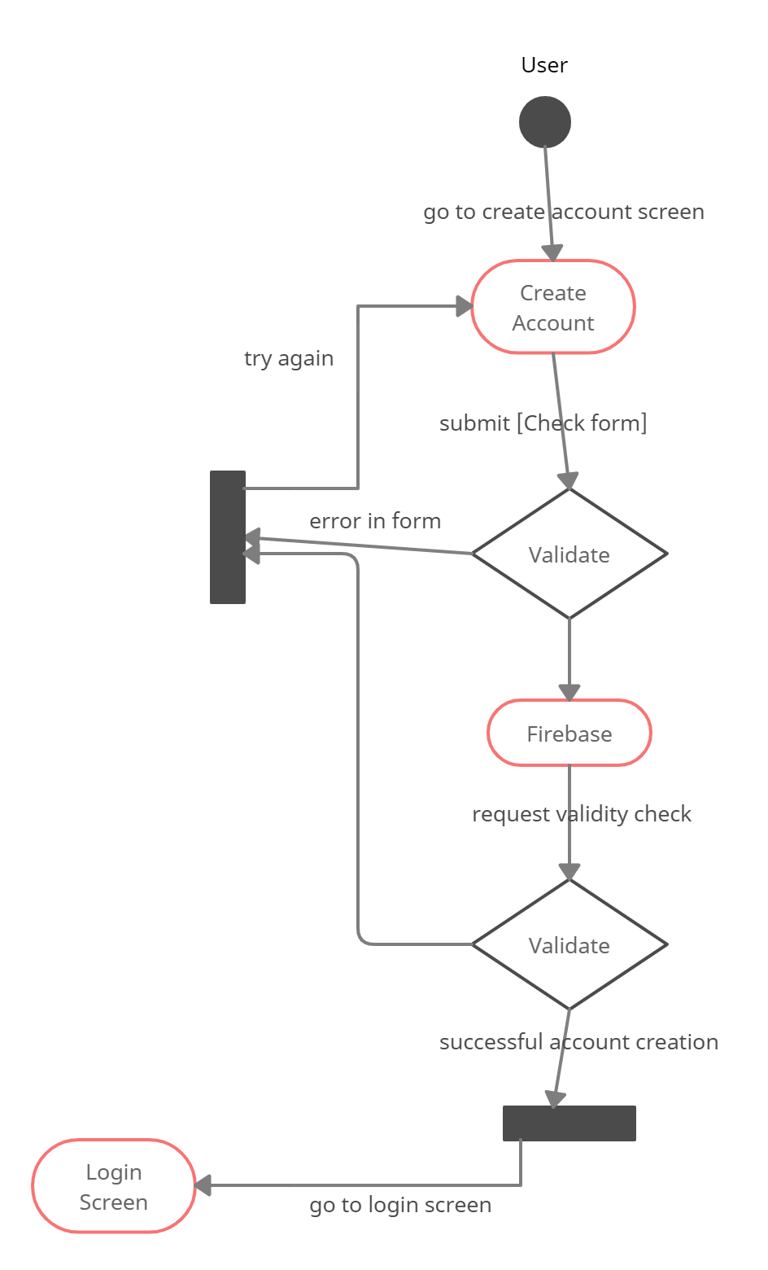

#### User Login

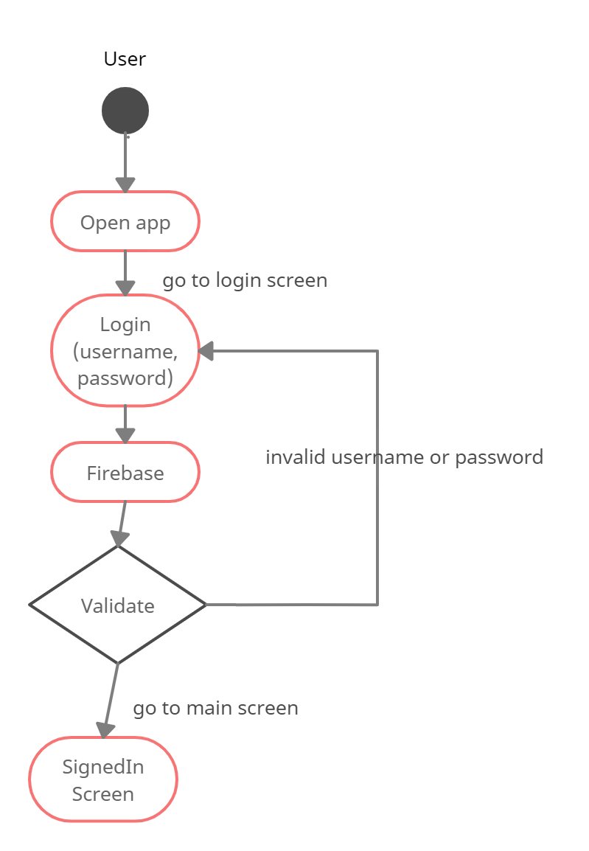

Chapter 5: User Manual



## Introduction

**Tour Guide** is a Mobile application. This system is characterized by its user-friendly interfaces. It is divided into screens according to the user who will deal with it.

A **mobile application**, most commonly referred to as an **app**, is a type of **application** software designed to run on a **mobile** device, such as a smartphone or tablet computer. **Mobile applications** frequently serve to provide users with similar services to those accessed on PCs Some software uses these languages to build our own applications.

Other software we need to build databases is also used in our applications, so we need software for building databases.

## Hardware Requirements

1. A Mobile with internet

## Software Requirements:

1. Android Studio
2. Firebase

## Figures of the project:

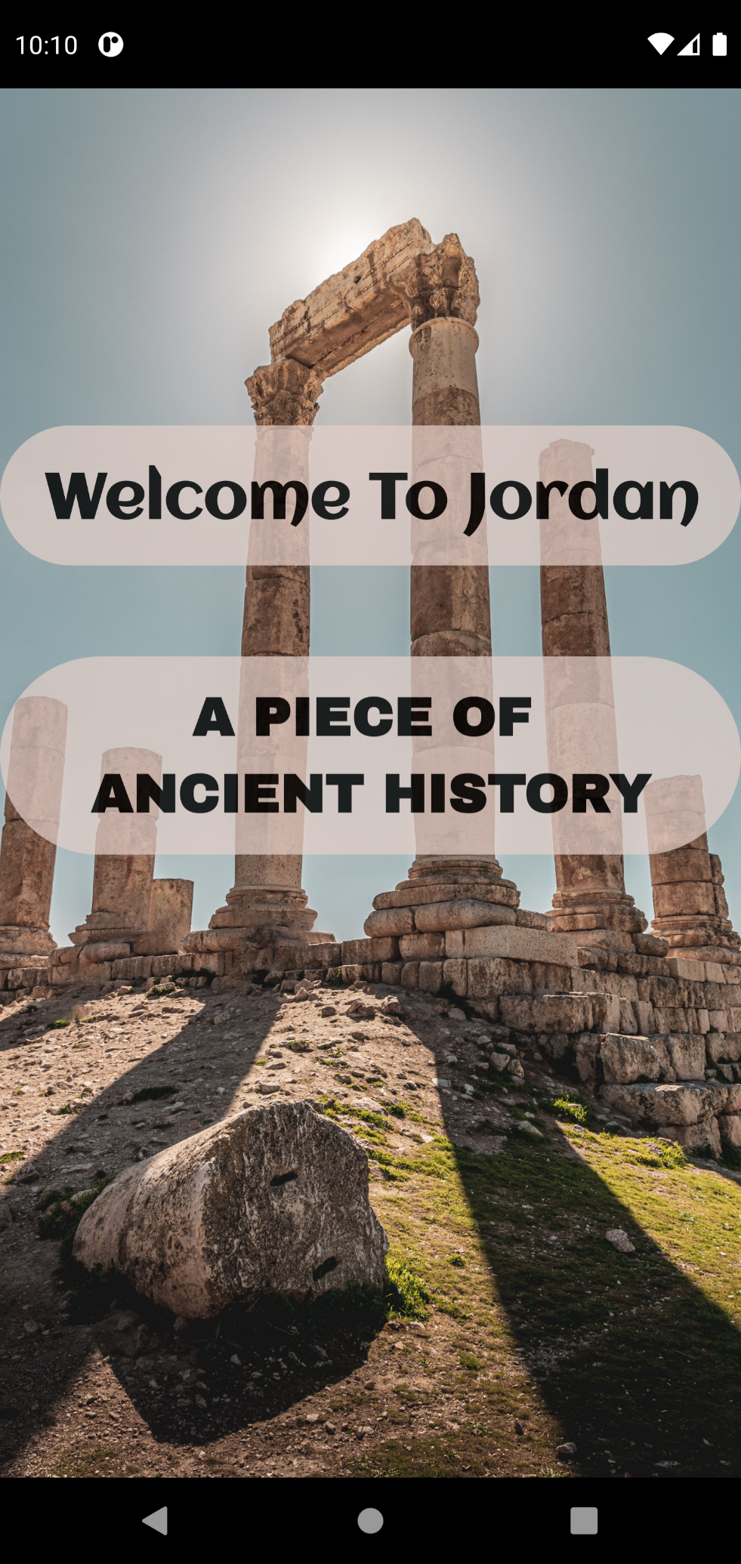

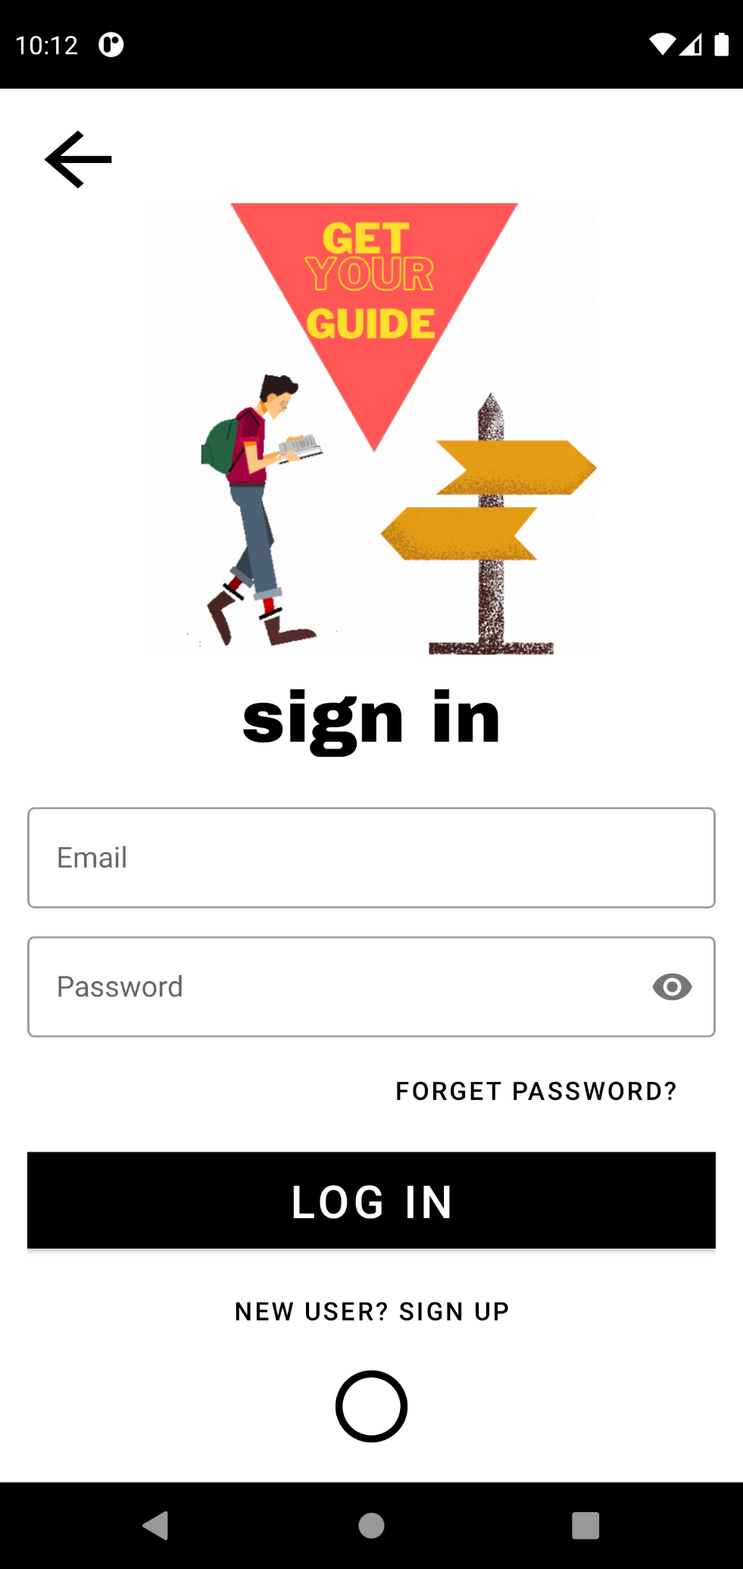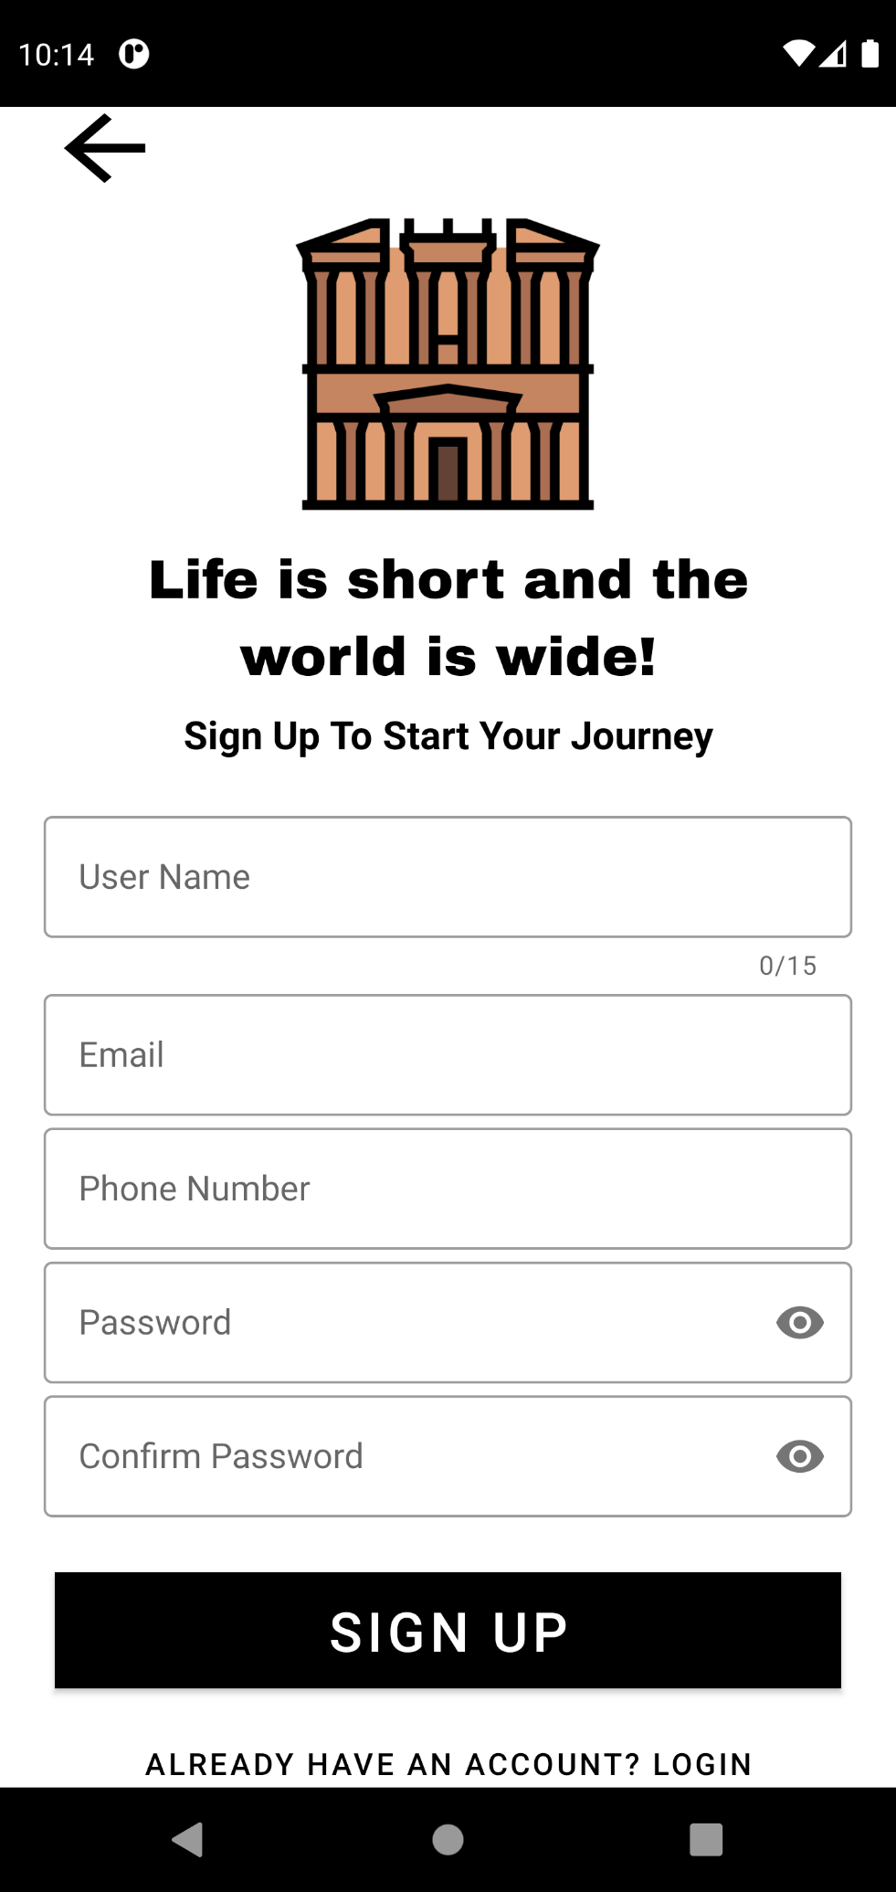

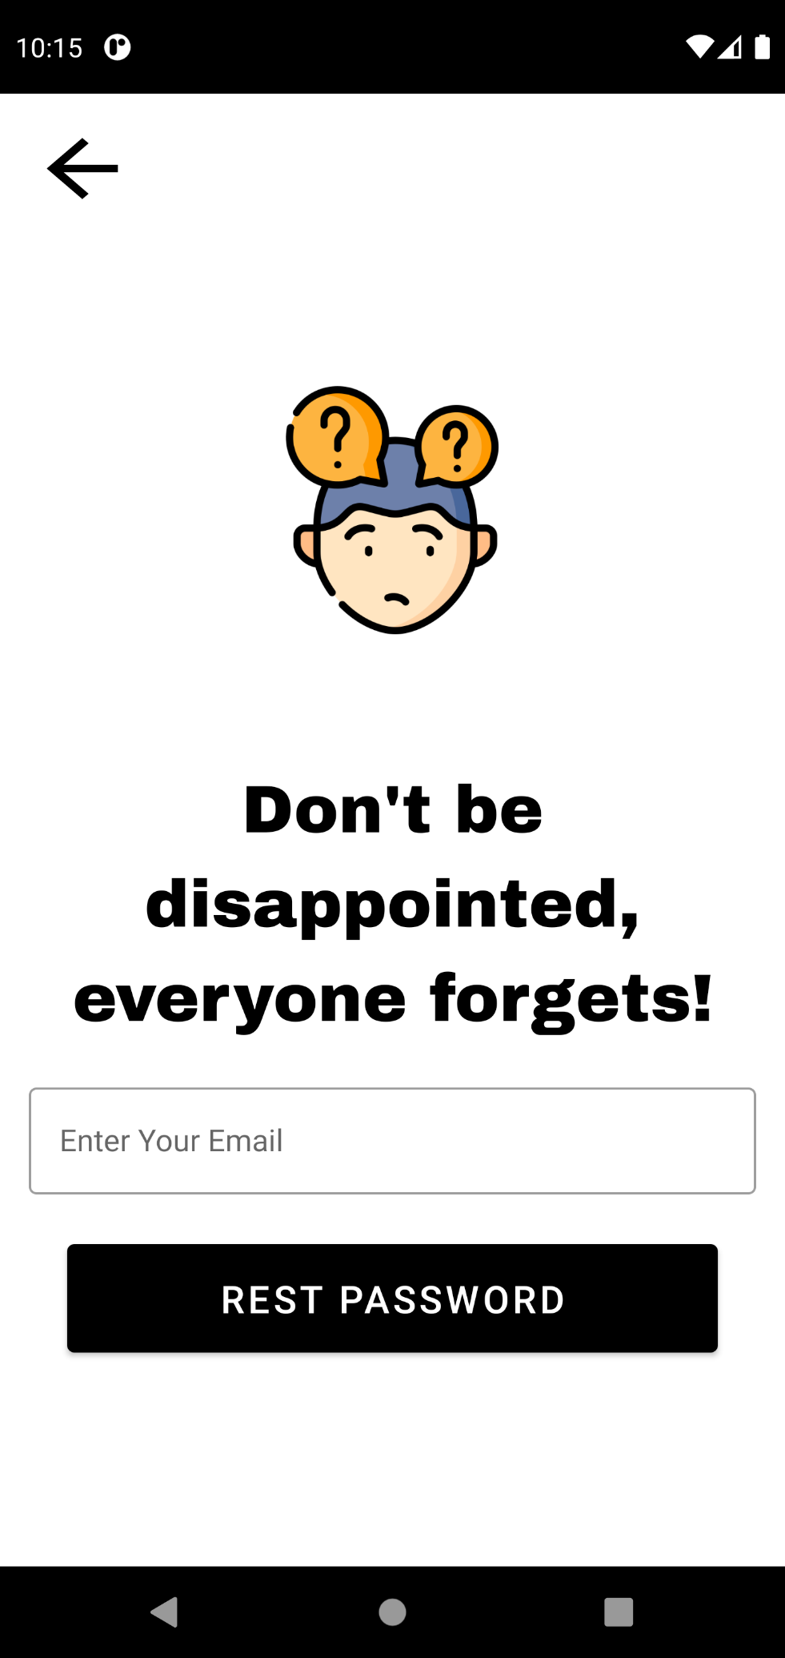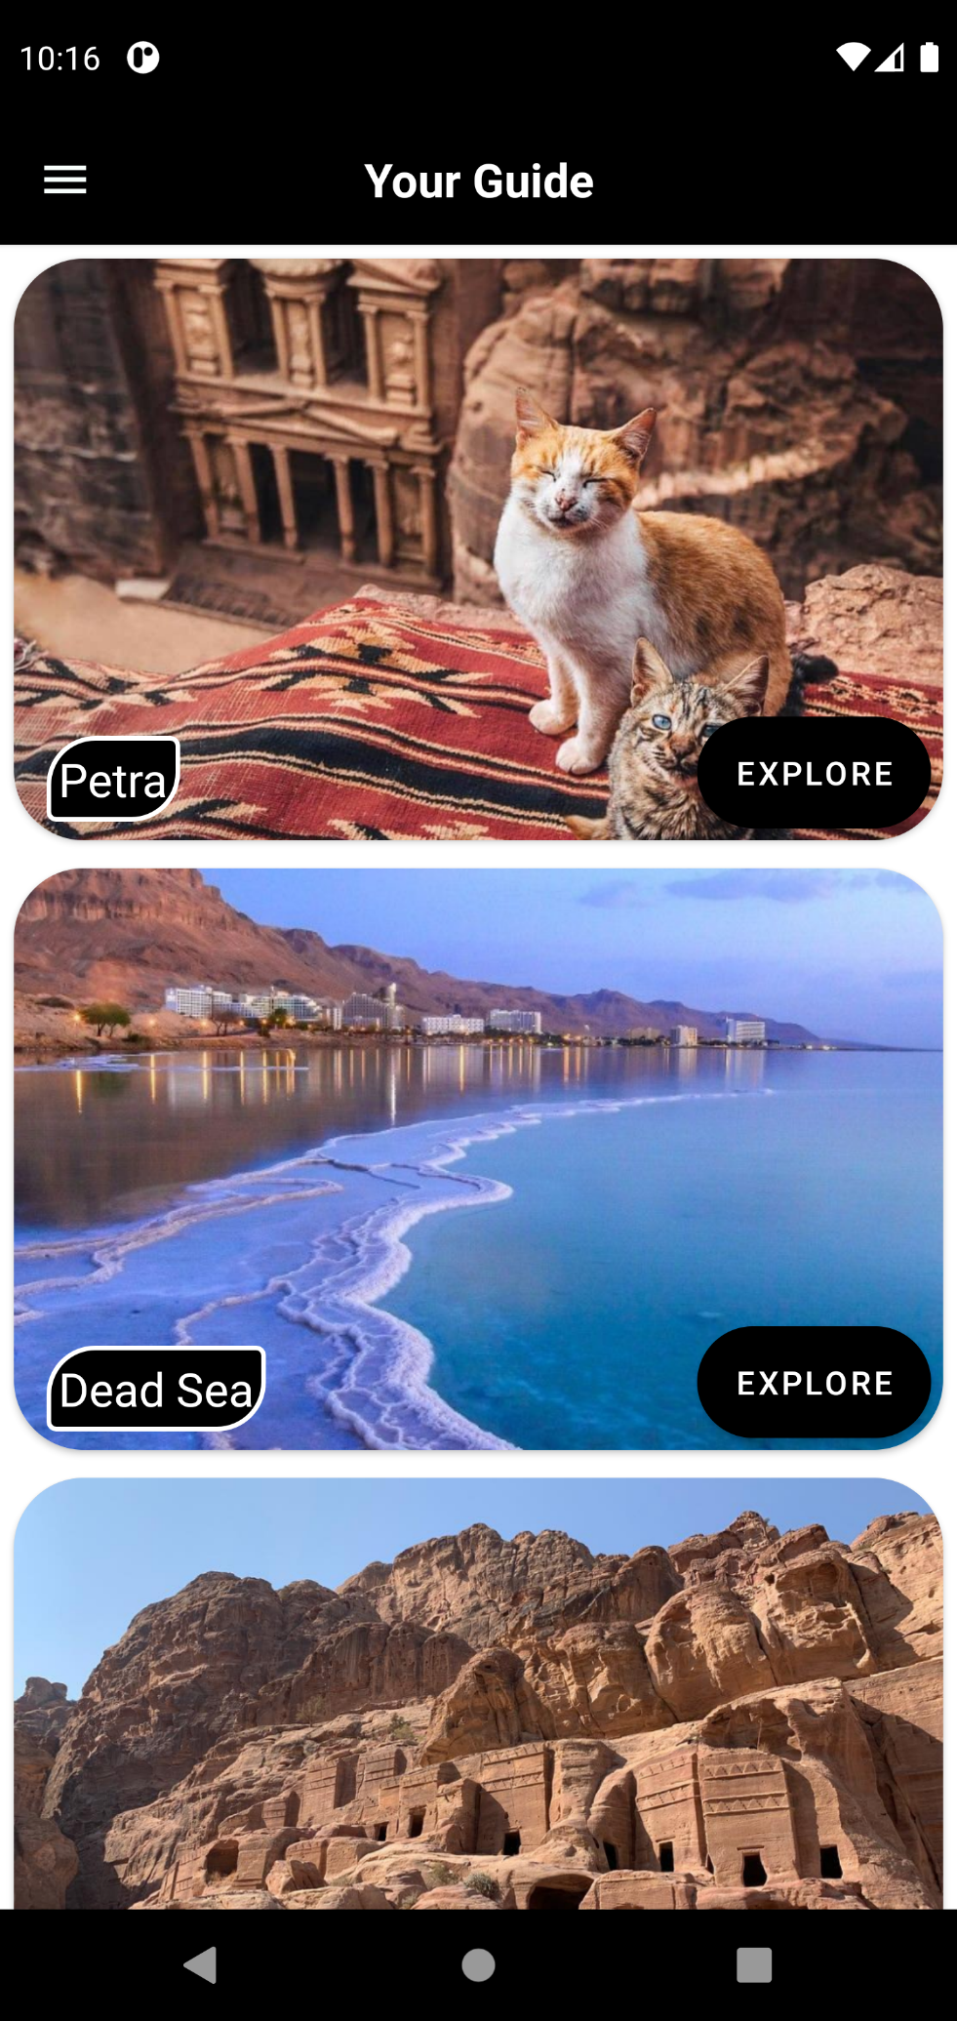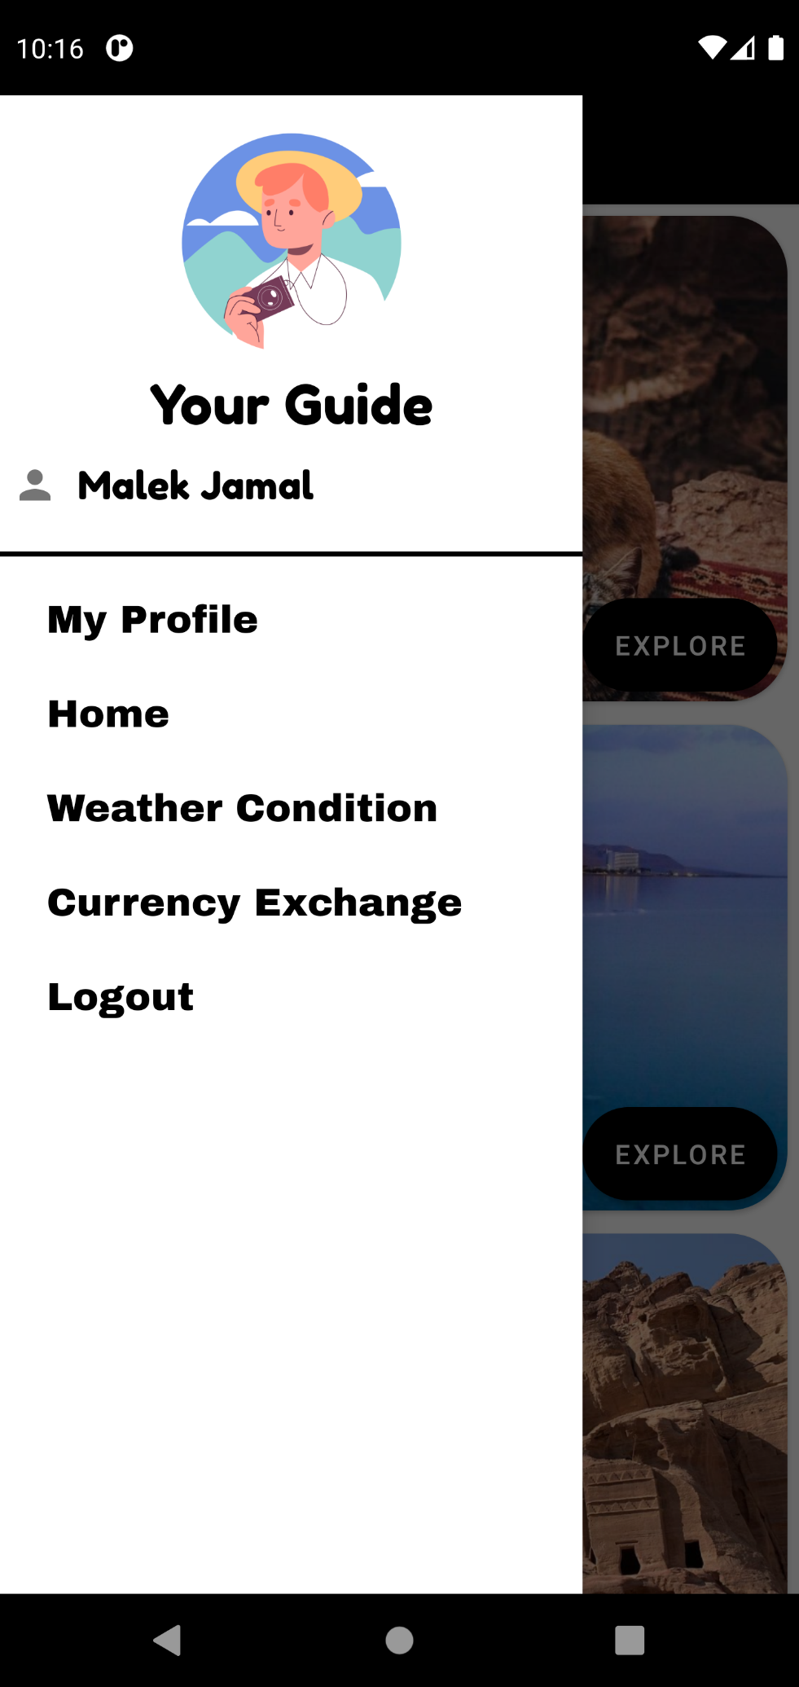

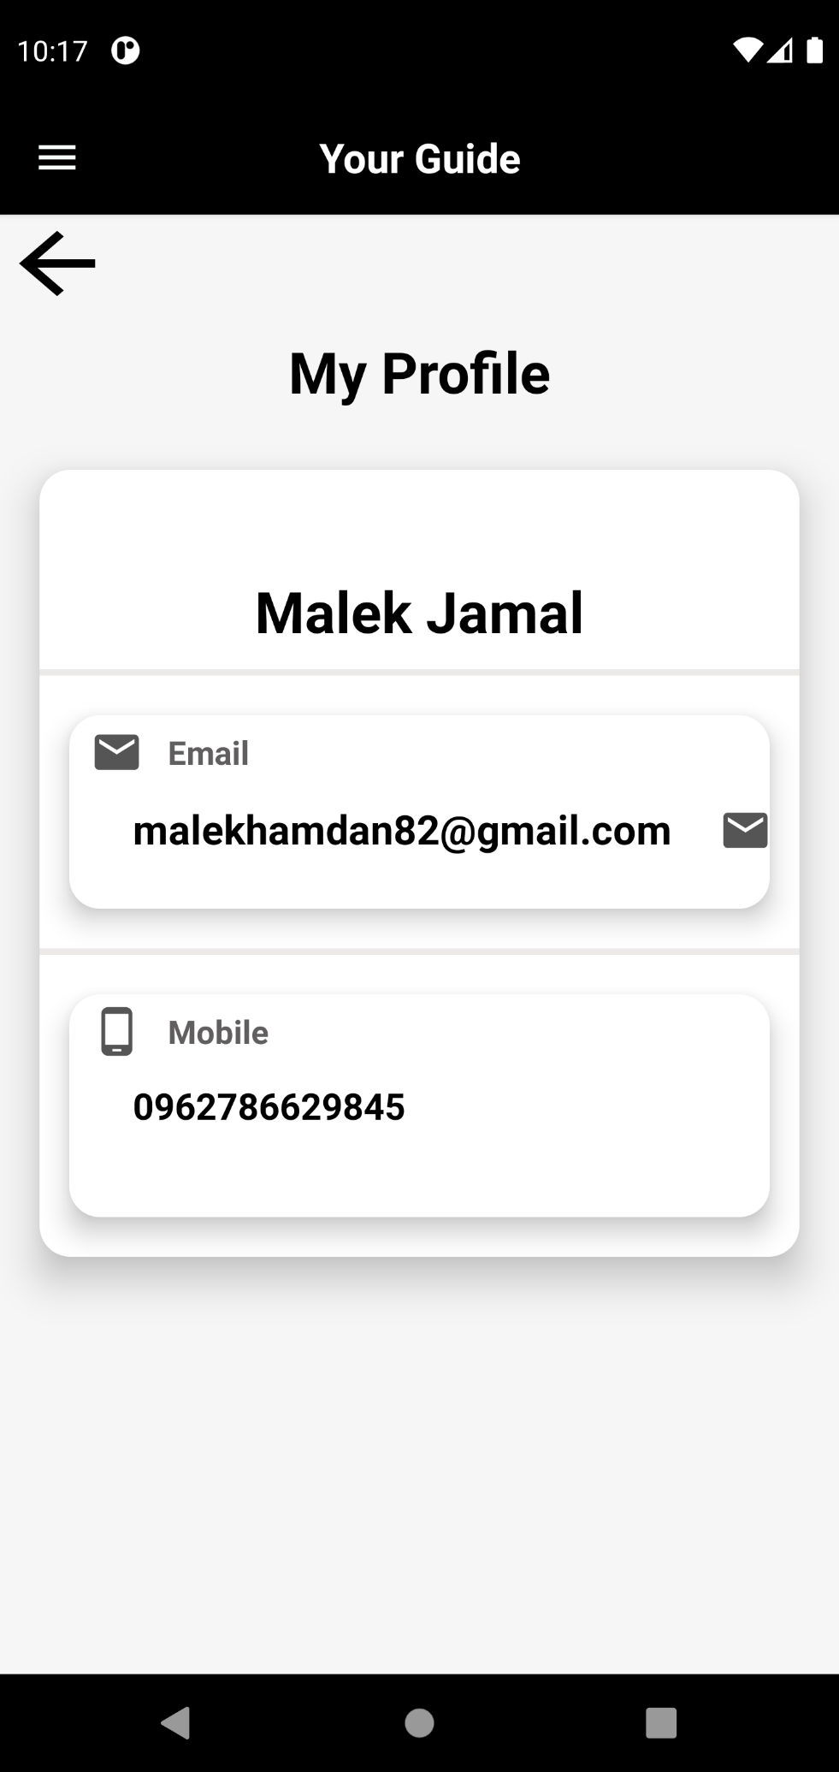

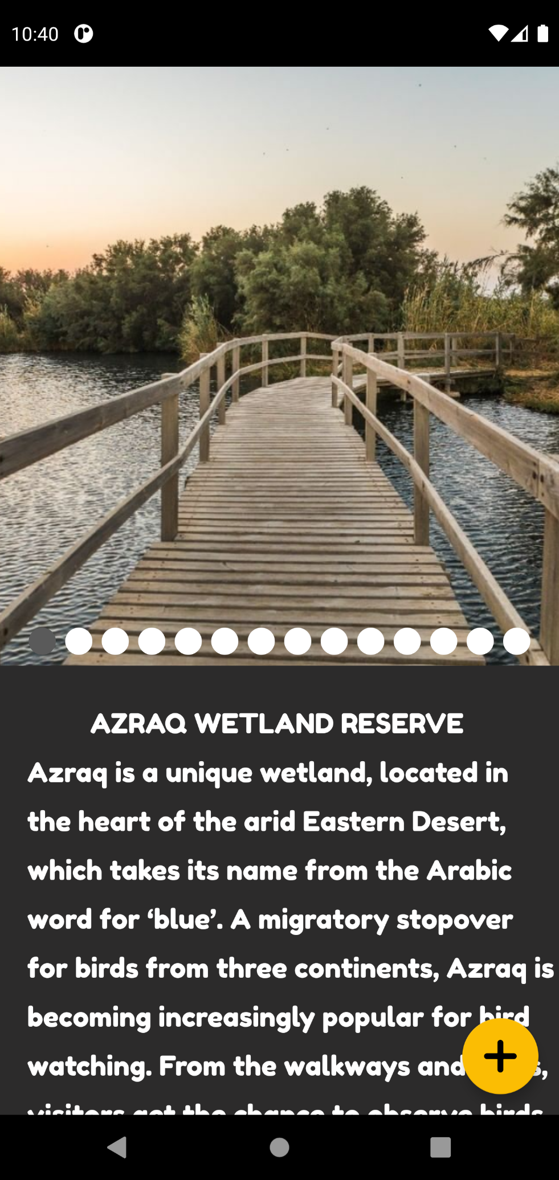

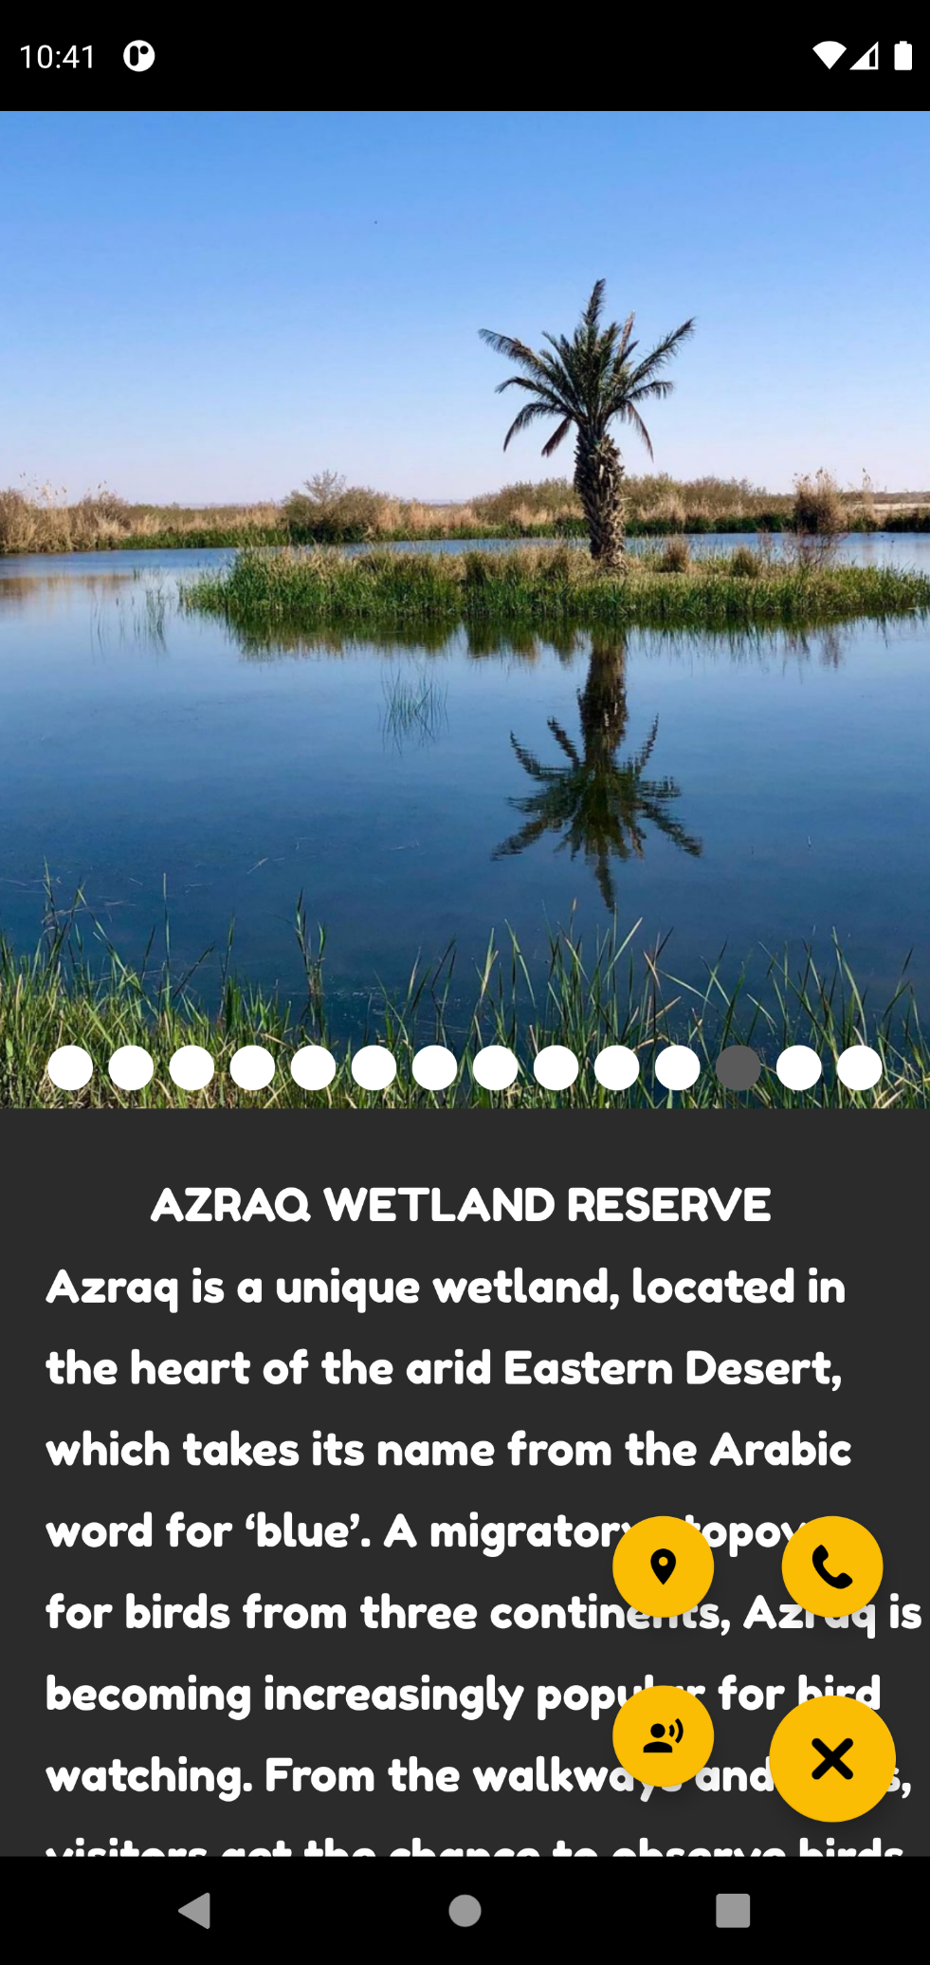

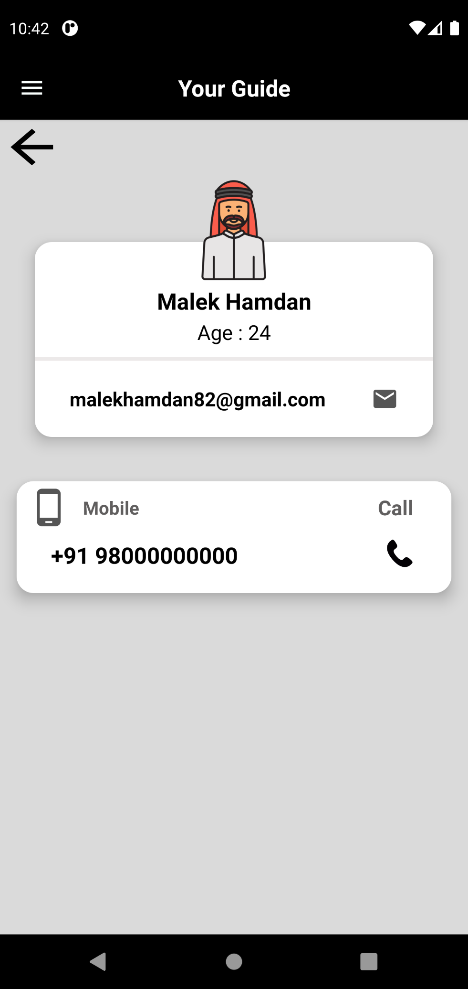

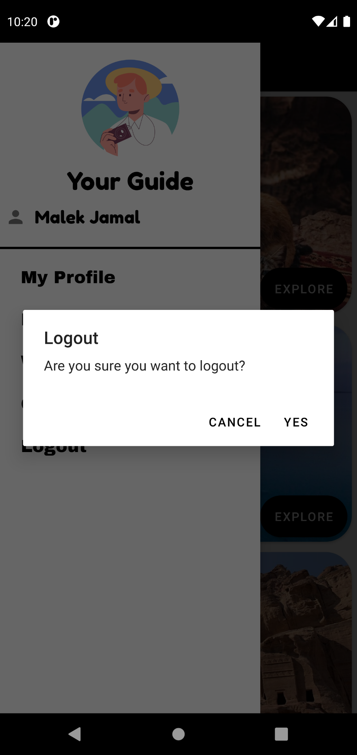

## References

## **Photos and Icons**

Material Design

flaticon

**SDLC "System Development Life Cycle"**

Tutorialspoint

<https://www.tutorialspoint.com/sdlc/>

**UML Diagrams**

Tutoralspoint

<https://www.tutorialspoint.com/uml/uml_standard_diagrams.htm>

**Wikipedia**

[https://en.wikipedia.org/wiki/Category:Archaeological_sites_in_Jordan](%20https:/en.wikipedia.org/wiki/Category:Archaeological_sites_in_Jordan)

**Pexels**

[**https://www.pexels.com/**](https://www.pexels.com/)

**universes.art**

[**https://universes.art/**](%20%20%20%20%20https:/universes.art/)

**Ma'wa**

[**https://www.almawajordan.org/**](%20%20%20%20%20https:/www.almawajordan.org/)

**Visit Jordan**

[**http://www.visitjordan.com/**](http://www.visitjordan.com/)

